A000-Afr-Egy-Dynasty XVIII-PTAH-Statue-Chlorite

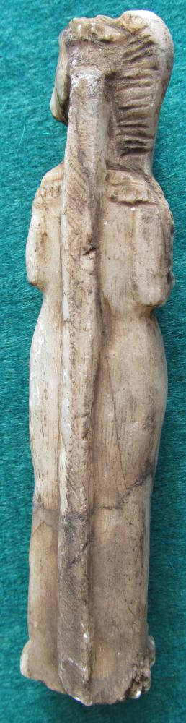 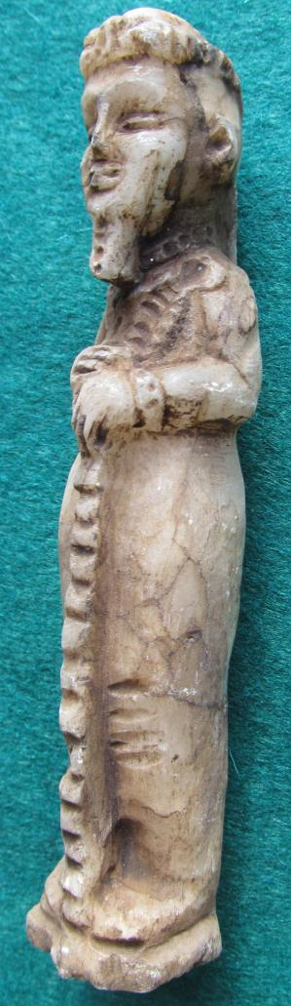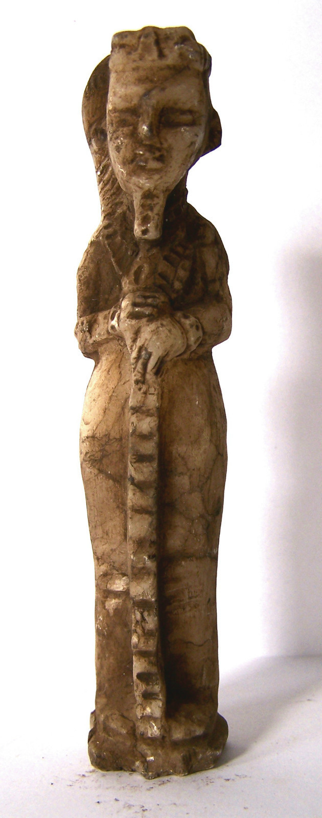 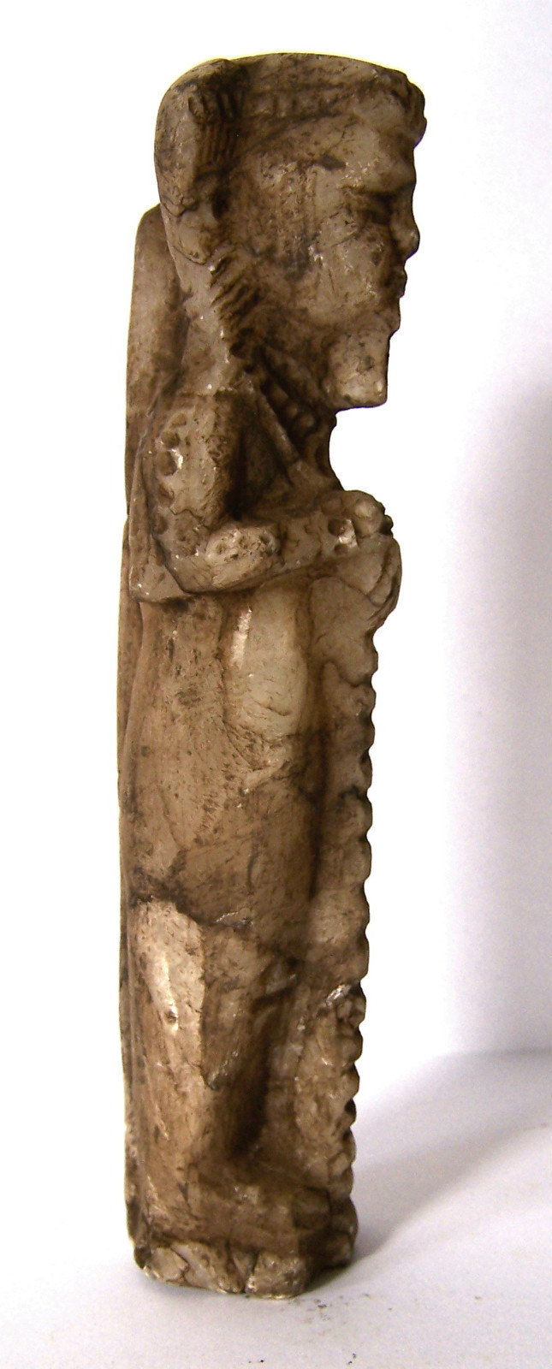

Figurine of Ptah, Memphis, Dynasty 18, reign of Amenhotep III - Tutankhamun (1390-1322 BCE)

Case no. 2

BL2450.P7

Statuette of Ptah

Height:

Weight:

Ptah, god of craftsmen, was father of Nefertum and Imhotep. Nefertum was represented both the first sunlight and the emerging blue lotus flower ([*Nymphaea caerulea*](https://en.wikipedia.org/wiki/Nymphaea_caerulea)) from the primal waters. Imhotep was regarded also as the god of craftsmen and architects (a knowledge passed on from Ptah) and who was subsequently regarded as the earliest known architect and engineer *in* history. Imhotep was king Djoser’s architect of the Step Pyramid, which was built ca. 2650–2600 BCE, and he was also high priest of the sun god Ra at Heliopolis. Ptah’s wife was Sekhmet the lioness-headed goddess. Here, Ptah is shown wearing a beard (divine symbol) and a single braid on his right side. He holds the djed, perhaps in this case an instrument of measurement as it is prominently grooved horizontally. Perhaps, this statuette was once the amulet of an Egyptian engineer. As the god of craftsmen, the Ptah cult spread throughout Egypt from the Old Kingdom onwards.

References

Kemp, Barry J. 2005. *Ancient Egypt*. London: Routledge.

Holmberg, Sandman. 1946. *The God Ptah*. Lund: C.W.K. Gleerup .